Steven Mathias
7/26/2026
CS 499 Capstone
Module Four

Enhancement Two: Narrative
For enhancement two, I chose to perform an enhancement of the Course Planner C++ program that was originally made for CS 300. This program presents the user with a menu to load data from a course list file, and once loaded, print a list of all courses, print a specific course, or exit the program. The program parses each line of the file loaded and stores the Course ID, name and prerequisites.
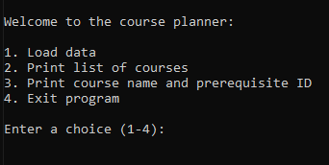
As the 2nd category for enhancement is titled “Algorithms and Data Structures”, I decided to enhance this artifact by upgrading the simple unordered_map that is currently built into the program and replace it with a node based linked list. This will demonstrate my ability to work with different types of data structures, as well as modify existing project architecture while not compromising the original functionality.
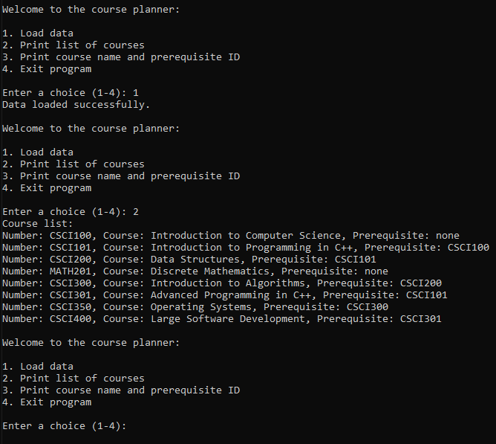
Some of the aspects of the new code include node structure to establish a new node to hold a single course’s information, then incorporate pointers to connect all the nodes in a chain, that the program can then start from the beginning to search for specific data or print in alphanumerical order.
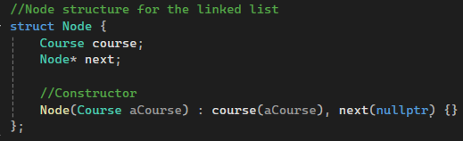
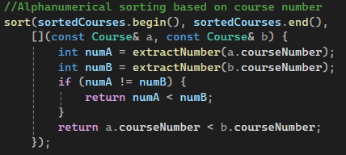
In addition, I included a crucial element to the overall system architecture that deallocates memory in the list. Without this “clearList” function, each time a user selected to load data, the original data would remain in the memory. This data builds up and could result in memory leaks. This could slow the memory and eventually crash the program. By calling clearList(head), we are clearing out the data before loading new data.
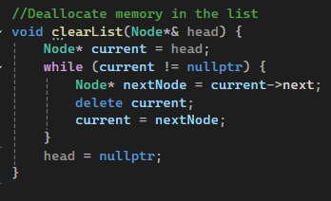
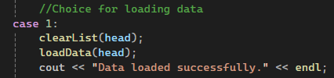

I do believe that I am continuing to demonstrate the ability to satisfy the course outcomes with this enhancement. This enhancement required an ability to identify an area for improvement regarding data structures, design, build and finalize the improvement. As the overall architecture has been reconfigured with the addition of the linked list data structure, I am prepared to begin the final enhancement. This course planner program, artifact two, will also be used to satisfy enhancement three for databases. The courser planner will be upgraded to include authentication methods to verify a standard user or an admin via an SQLite database. If the user is an admin, CRUD operations will be given to modify course data.
